DevSecOps Engineering and Automation Workshop
Using Testing Tools - JMeter

© 2013-2024 NUS. The contents contained in this document may not be reproduced in any form or by any means, without the written permission of NUS-ISS, other than for the purpose for which it has been supplied.
INSTRUCTIONS
This is an exercise in load and performance testing using JMeter.
It can be performed by teams of two.

Specific instructions are given at the end of each step that you will need to follow. You will work in the same team throughout the workshop. It would take from 70 to 90 Minutes to complete the workshop.

JMeter Setup & Start
Download the JMeter: https://jmeter.apache.org/download_jmeter.cgi

Binaries Zip File: apache-jmeter-5.6.3.zipsha512pgp

Extract the zip fle and locate the folder: C:\apache-jmeter-5.5\bin and double clicking jmeter.bat (Windows Batch File) to run JMeter.

Run JMeter Wizard.

Exercise
In this workshop, you will learn how to create a basic Test Plan to test a web site. You will create five users that send requests to two pages on the website. Also, you will tell the users to run their tests twice. So, the total number of requests is (5 users) x (2 requests) x (repeat 2 times) = 20 HTTP requests. To construct the Test Plan, you will use the following elements: Thread Group, HTTP Request, HTTP Request Defaults, and Graph Results.

Step 1: Adding Users
- The first step you want to do with every JMeter Test Plan is to add a Thread Group element. The Thread Group tells JMeter the number of users you want to simulate, how often the users should send requests, and the how many requests they should send.
- Go ahead and add the ThreadGroup element by first selecting the Test Plan, clicking your right mouse button to get the Add menu, and then select Add --> ThreadGroup.
- You should now see the Thread Group element under Test Plan. If you do not see the element, then "expand" the Test Plan tree by clicking on the Test Plan element. Next, you need to modify the default properties. Select the Thread Group element in the tree, if you have not already selected it. You should now see the Thread Group Control Panel in the right section of the JMeter window (see Figure 1 below)
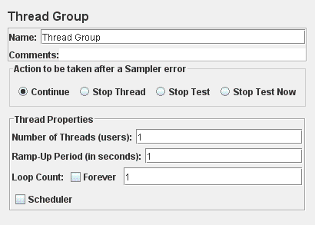
Figure 1. Thread Group with Default Values
- Start by providing a more descriptive name for our Thread Group. In the name field, enter Apache Users.
- Next, increase the number of users (called threads) to 5. In the next field, the Ramp-Up Period, leave the default value of 1 second. This property tells JMeter how long to get all the users started. For example, if you enter a Ramp-Up Period of 5 seconds, JMeter will finish starting all of your users by the end of the 5 seconds. So, if we have 5 users and a 5 second Ramp-Up Period, then the delay between starting users would be 1 second (5 users / 5 seconds = 1 user per second). If you set the value to 0, then JMeter will immediately start all of your users.
- Finally enter a value of 2 in the Loop Count field. This property tells JMeter how many times to repeat your test. If you enter a loop count value of 1, then JMeter will run your test only once. To have JMeter repeatedly run your Test Plan, select the Forever checkbox. (See Figure 2 for the completed Apache Users Thread Group.)
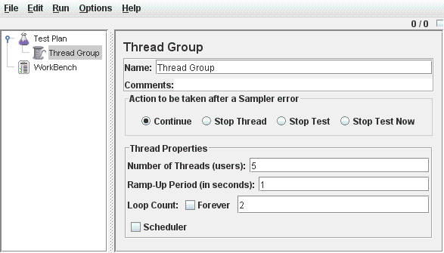
Figure 2. Apache Users Thread Group

Step 2: Adding Default HTTP Request Properties
- Now that we have defined our users, it is time to define the tasks that they will be performing. In this section, you will specify the default settings for your HTTP requests.
- Begin by selecting the Apache Users (Thread Group) element. Click your right mouse button to get the Add menu, and then select Add --> Config Element --> HTTP Request Defaults. Then, select this new element to view its Control Panel (see Figure 3).
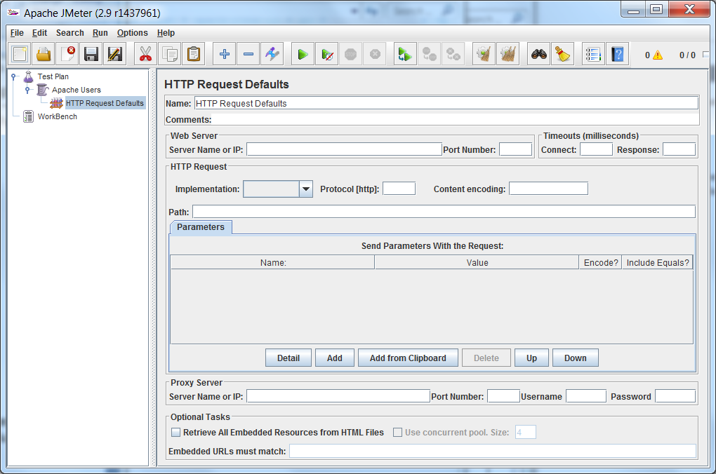
Figure 3. HTTP Request Defaults
- Like most JMeter elements, the HTTP Request Defaults Control Panel has a name field that you can modify. In this example, leave this field with the default value.
- For the Test Plan that you are building, all HTTP requests will be sent to the same Web server, www.frugaltesting.com Enter this domain name into the field. This is the only field that we will specify a default, so leave the remaining fields with their default values. The HTTP Request Defaults element does not tell JMeter to send an HTTP request. It simply defines the default values that the HTTP Request elements use. See Figure 4 for the completed HTTP Request Defaults element
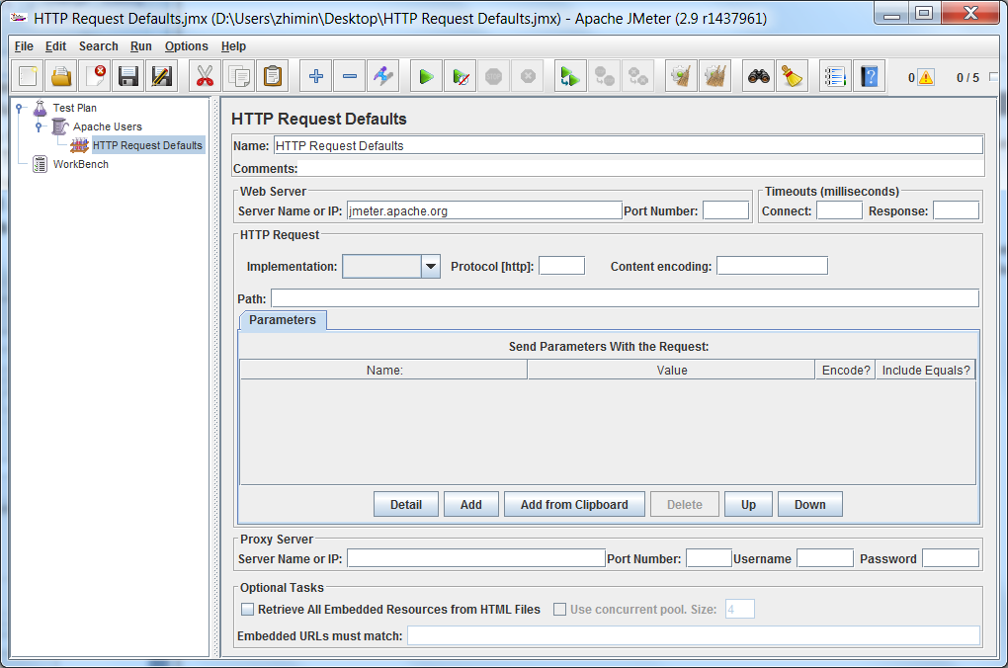
www.frugaltesting.com
Figure 4. HTTP Defaults for our Test Plan

Step 3: Adding Cookie Support
- Nearly all web testing should use cookie support, unless your application specifically doesn't use cookies. To add cookie support, simply add an HTTP Cookie Manager to each Thread Group in your test plan. This will ensure that each thread gets its own cookies, but shared across all HTTP Request objects.
- To add the HTTP Cookie Manager , simply select the Thread Group , and choose Add --> Config Element --> HTTP Cookie Manager, either from the Edit Menu, or from the right-click pop-up menu.

Step 4: Adding HTTP Requests
- In our Test Plan, we need to make two HTTP requests. The first one is for the home page, and the second one is for getting direction. JMeter sends requests in the order that they appear in the tree.
- Start by adding the first HTTP Request to the Apache Users element (Add --> Sampler --> HTTP Request). Then, select the HTTP Request element in the tree and edit the following properties (see Figure 5):
  - Change the Name field to "Home Page".
  - Set the Path field to "/". Remember that you do not have to set the Server Name field because you already specified this value in the HTTP Request Defaults element.
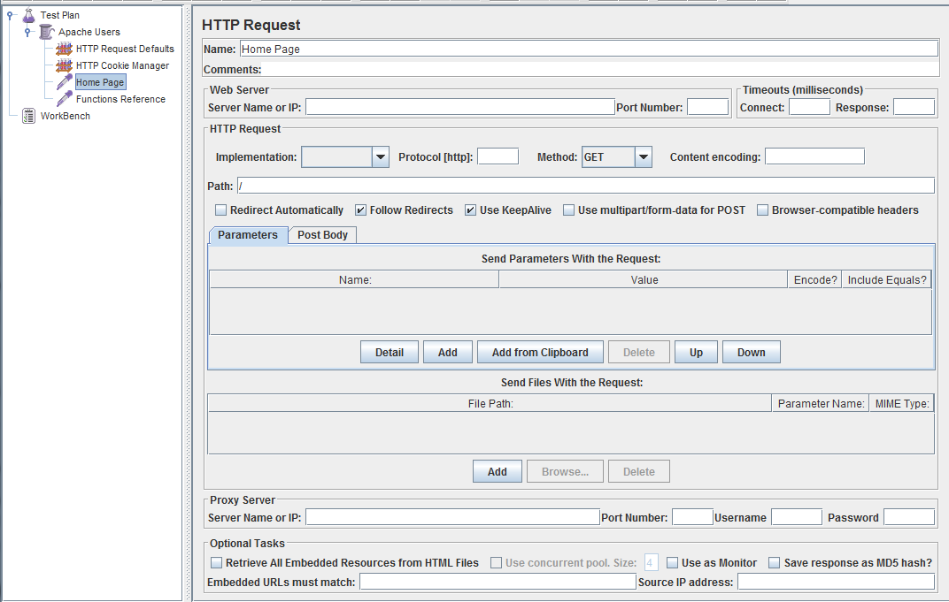
Figure 5. HTTP Request for JMeter Home Page

- Next, add the second HTTP Request and edit the following properties (see Figure 6)
  - Change the Name field to "Direction ".
  - Set the Path field to "/www.frugaltesting.com/contact-us".
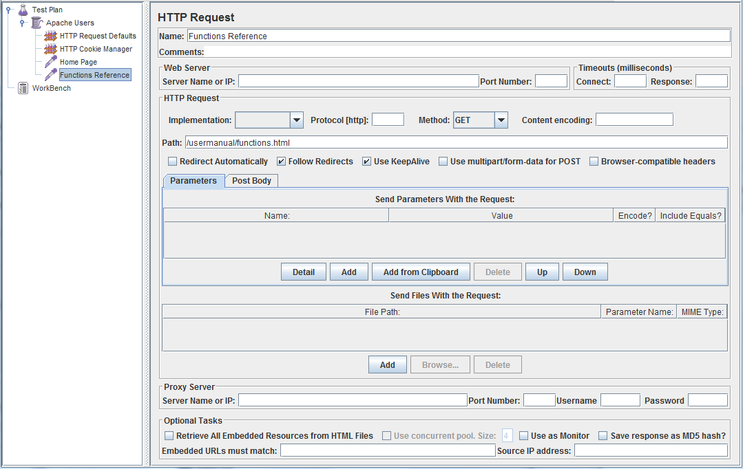
www.frugaltesting.com/contact-us
Figure 6. HTTP Request for JMeter Functions Reference Page

Step 5: Adding a Listener to View the Test Results
- The final element you need to add to your Test Plan is a Listener. This element is responsible for storing all of the results of your HTTP requests in a file and presenting a visual model of the data.
- Select the Apache Users element and add a Graph Results listener (Add --> Listener --> Graph Results). Next, you need to specify a directory and filename of the output file. You can either type it into the filename field, or select the Browse button and browse to a directory and then enter a filename.
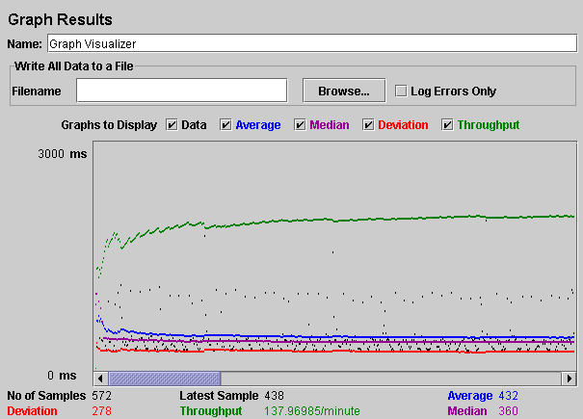
Figure 7. Graph Results Listener

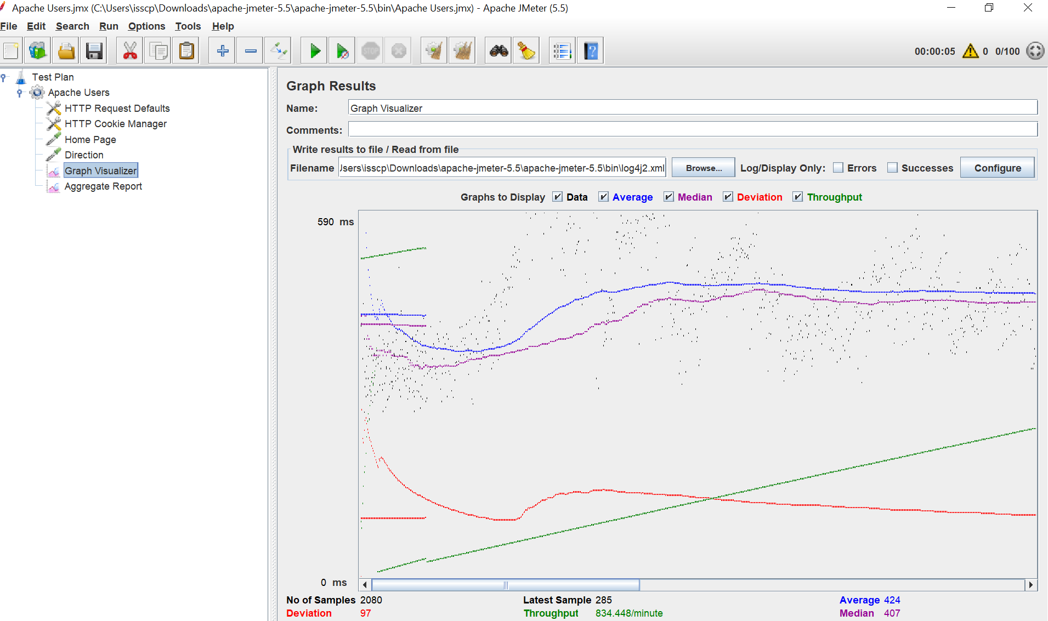

- Another useful Listener is Aggregate Report (Add --> Listener --> Aggregate Report).

Step 5: Run the Test Plan and view the test results
- Save the TestPlan in D:\S-ST folder by name MyFirstTestPlan.
- Now it’s time to run the Test plan by selecting Run from the menu and then select Start (or Ctrl-R).

Data provided by Listener:
- #Samples: Total number of Samples.
- Average: Average Time.
- Min: This is the minimum time a sampler has taken to go to the server.
- Max: This is the maximum time request taken to go to the server.
- Error%: Number of error sampler/Total number of Sampler.
- Throughput: Throughput is per second sample received by the server.
- Received KB/second: This defines how many kilobytes per second received by the Client.
- Sent KB/second: This defines how many Kilobytes per second are sent to the server.
- 90% Line: It represents that 10% of the samplers have exceeded time to reach the server.
- 95% Line: It represents that 5% of the samplers have exceeded time to reach the server.
- 99% Line: It represents that 1% of the samplers have exceeded time to reach the server.

Explanation:

- # Samples
  - Total number of requests (samplers) sent.
  - Unit: Count (integer)
- Average
  - The mean response time across all samples.
  - Unit: Milliseconds (ms)
- Min
  - The fastest (shortest) response time recorded.
  - Unit: Milliseconds (ms)
- Max
  - The slowest (longest) response time recorded.
  - Unit: Milliseconds (ms)
- Error %
  - The percentage of samplers that resulted in errors
=(error−count/total−count)×100= (error-count / total-count) × 100=(error−count/total−count)×100
  - Unit: Percent (%)
- Throughput
  - Number of requests completed by the server per second.
  - Unit: Requests / second (requests)
- Received KB/sec
  - Amount of data the client downloaded per second.
  - Unit: Kilobytes / second (KB)
- Sent KB/sec
  - Amount of data the client uploaded per second.
  - Unit: Kilobytes / second (KB)
- 90 % Line (90th percentile)
  - Response time below which 90 % of samples fall (i.e. only 10 % are slower).
  - Unit: Milliseconds (ms)
- 95 % Line (95th percentile)
  - Response time below which 95 % of samples fall (i.e. only 5 % are slower).
  - Unit: Milliseconds (ms)
- 99 % Line (99th percentile)
  - Response time below which 99 % of samples fall (i.e. only 1 % are slower).
  - Unit: Milliseconds (ms)

Note on percentiles (90 %, 95 %, 99 %):
These give you a view of the “tail” of your response-time distribution—useful for seeing how bad the worst 10 %, 5 %, or 1 % of responses are, without being skewed by extreme outliers.

